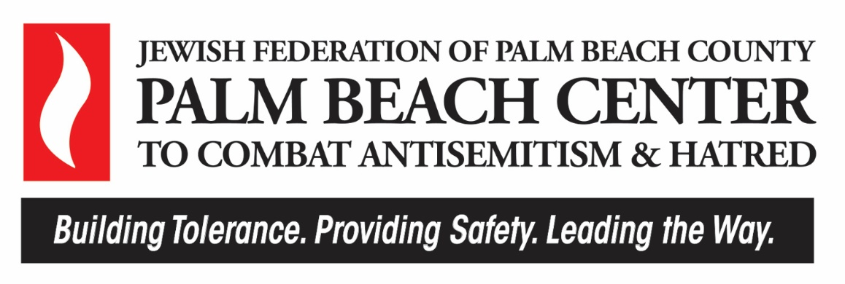

FALL 2025 GRANT GUIDELINES
& APPLICATION INSTRUCTIONS

FUNDING TO

COMBAT ANTISEMITISM, FIGHT HATRED, AND PROMOTE TOLERANCE

Funding is available to support innovation and encourage the following:
- Fostering deep allyships and relationships across communities
- Bringing people together to learn and build bridges
- Combating antisemitism and hatred
Key Dates
October 27, 2025 | Application and Grant Guidelines Available
November 10, 2025  10 to 11am | Virtual Information Session  CLICK HERE TO REGISTER
Through December 8, 2025 at 5pm | Technical Assistance Available
December 8, 2025 at 5pm | Deadline for Application Submission
Week of March 9, 2026 | Follow up for Applications Requiring Additional Information
Mid-April 2026 | Notification of Award
June 30, 2026 | All Funds Distributed
June 30, 2026 – June 30, 2027 | Grant Cycle Funding Period
ABOUT US AND OUR MISSION & VISION
JEWISH FEDERATION OF PALM BEACH COUNTY
Mission: Strengthen Jewish identity, energize the relationship with Israel and meet human needs that are uniquely the obligation of the Jewish community.
Vision: Developing the human and financial resources necessary to ensure a vibrant Jewish future.
PALM BEACH CENTER TO COMBAT ANTISEMITISM & HATRED
The Palm Beach Center, an innovative initiative of Jewish Federation of Palm Beach County, aims to strengthen local efforts and resources in combating antisemitism. It is designed to foster collaboration, coordination, and partnerships to address the urgent needs of Jewish Palm Beach. Priorities include (1) fostering tolerance and creating allies in the non-Jewish community, (2) ensuring the safety and security of Jewish community institutions and synagogues, and (3) leading the way to identify and execute strategies that directly confront local antisemitism and hatred.
Palm Beach Center Mission: Lead a county-wide strategy to counter antisemitism, ensuring a secure Jewish future and nurturing a tolerant community. Through collaboration, we provide strategic and financial assistance to Jewish partners and others, exemplifying local leadership.
Now is the Time:
- For the first time in the history of American Jewish Committee (AJC)’s State of Antisemitism in America Report, a majority (56%) of American Jews report changing their behavior out of fear of antisemitism.
- Florida ranks seventh in the nation for antisemitic incidents, with Palm Beach County reporting the highest number among all counties in the state.
- Despite Jews representing only 3.1 percent of the state’s population, antisemitic hate crimes make up 80% of religiously motivated crimes in Florida.
Sources: ADL, FBI, Hadassah, AJC

PURPOSE AND FOCUS FOR THIS GRANT FUNDING
Below are key objectives and examples of eligible projects within these areas:
- Increase the active participation of influential figures beyond the Jewish community who publicly address and denounce antisemitism and hatred.
- Establish partnerships with influential individuals and organizations from various sectors to combat antisemitism through legislative efforts, educational policies, and curricula development.
- Develop diverse and impactful programming that promotes understanding, tolerance, and unity for all of Palm Beach County.
The following list includes examples of projects that would be eligible for this grant funding. However, applications and projects are not limited to these examples. We strongly encourage innovation.
Click here for a list of projects funded last cycle.
Examples of Eligible Projects:
- Coalition-building among different identity groups
- Events and activities that bring people together, including community meals
- Interfaith and cross-community service projects
- Projects in the arts – art, dance, music
- Projects within the Education Sector: Early Childhood, K-12, Higher Education, Adult Learning
- Educational lectures and speaker series
- Legal Consultation
- Projects that target misinformation and encourage meaningful dialogue
- Tackling media challenges, social media, and technology
Applicants should demonstrate a deep commitment to combating antisemitism and hatred. We strongly encourage innovation and involvement of the intended community and participants in project planning.
ELIGIBILITY
Applicants must demonstrate the following:
- Programming and/or services that benefit Palm Beach County and its residents. There is a preference for organizations with a physical presence in Palm Beach County.
- Status as a nonprofit, government, Federation Jewish partner, and/or other religious entity (please attach appropriate documentation within application). Use of a fiscal sponsor that meets one of these categories is also acceptable.

FUNDING AND SPENDING GUIDELINES
Time Period: Grants will be awarded for up to a one-year period. We will not fund multi-year proposals. Dollars must be used by June 30, 2027.
This funding is designed to support specific projects and initiatives with outcomes that can be measured. General operational support for an organization is NOT covered by these grants.
REVIEW PROCESS
Eligible proposals will be reviewed and evaluated by Federation staff and members of the Grant Selection Committee. There is no formal interview or site visit during the review process; however, we may contact applicants for additional information or clarification. If additional information is requested, follow-up will be conducted during the week of March 9th, 2026. Not providing responses during the review process could affect applicant standing. Reviewers will consider the following:
- Alignment with Grant Purpose
- Potential Impact
- Innovation
- Feasibility of Project Details
- Strength of Organization and alignment to mission
- Strength of Staffing Plan
- Strength of Partnerships and Collaborations
- Evaluation Plan
- Budget Appropriateness to Size and Scope of Proposal
In addition, reviewers will consider the overall slate of submissions and opportunities for impact.
Applicants must not use ChatGPT or any other generative AI tool to produce content for their grant submission. Any review for grammar or spelling is acceptable.
GRANT REQUIREMENTS
We are committed to ensuring that all grant dollars are used effectively, transparently, and with measurable impact. To this end, grantees will work closely with Federation staff to establish clear success indicators, agree upon data collection strategies, and commit to accountability standards throughout the grant period. By accepting funding, grantees agree to the following requirements:

Ongoing Tracking and Updates
- Tailored Metrics: Collaborate with Federation staff to define specific, measurable, achievable, relevant, and time-bound (SMART) outcomes that align with the stated goals of the grant.
- Record-Keeping: Maintain accurate, up-to-date records of activities, expenditures, participant demographics, and progress against objectives. Records must be sufficiently detailed to permit audit or review if required.
- Milestone Monitoring: Provide timely updates on progress toward key milestones, including both successes and challenges. Updates may be requested in written form or through scheduled check-in meetings.
- Deviation Reporting: Promptly notify the Federation of any significant deviations from the approved project plan, budget, or timetable, along with corrective actions being taken.
- Media Documentation: Capture and share photos, videos, or other documentation of funded activities to assist the Federation in marketing, donor communication, and impact reporting.

Financial Accountability
- Dedicated Accounting: All grant funds must be maintained in a manner that allows for separate tracking and reporting of expenditures.
- Permissible Use: Funds must be used solely for the project outlined in the approved proposal. Shifts across major budget categories (e.g., staffing, program delivery, evaluation) in excess of 10% require prior written approval from the Federation.
- Audit Compliance: Grantees must make financial records related to the grant available for inspection upon request.

Reporting Requirements
- Mid-Cycle Report (Due January 4, 2027): Submit a narrative and financial report summarizing activities to date, progress against agreed-upon metrics, and any challenges encountered. This review will serve as an opportunity for mid-course correction.
- Final Report (Due June 30, 2027): Provide a comprehensive narrative and financial report that includes:
  - Summary of activities and outputs delivered
  - Progress toward short- and long-term outcomes
  - Participant and community impact, supported by data and testimonials
  - Financial statement detailing use of funds
  - Lessons learned and recommendations for future programming
- Supplemental Information: The Federation may request additional documentation as needed, including participant surveys, evaluation tools, or qualitative feedback, to ensure the impact of the grant is fully captured.

Continuous Learning and Collaboration
- Participation in Federation Cohorts: Grantees may be asked to participate in peer-learning sessions, workshops, or convenings hosted by the Federation to share insights, best practices, and outcomes across the grantee network.
- Knowledge Sharing: Grantees are encouraged to develop case studies, program briefs, or presentations that can be shared with donors, partners, and the wider community to strengthen collective impact.
INQUIRIES, CONTACTS, AND TECHNICAL ASSISTANCE
Please direct all questions related to eligibility and application submission to Isabel Joseph, Grants Program Officer, isabel.joseph@jewishpalmbeach.org or 561.242.6623.

APPLICATION INSTRUCTIONS
The application and all supporting documents will be submitted electronically using SurveyMonkey Apply.
Click on this link to access the application:
Palm Beach Center to Combat Antisemitism & Hatred Grant - Jewish Federation of Palm Beach County
The deadline for submission of a complete application with all required documents is
December 8, 2025 at 5 pm
Be sure you receive confirmation from SurveyMonkey Apply stating that your application has been received. It is important to check for emails from SurveyMonkey Apply to make sure they do not end up in your spam or junk email folders.
The Application text is included on the following pages to assist with your preparation in completing the application process. We recommend printing a copy of the blank application to familiarize yourself with the questions. We also recommend initially typing your responses into a Word document. Then, when you are ready with all your responses, paste the text into the appropriate fields of the SurveyMonkey Apply application and/or be ready to upload the appropriate and requested documents.
There is a specific form required for submission of the Program Budget. This is available within the SurveyMonkey Apply application.
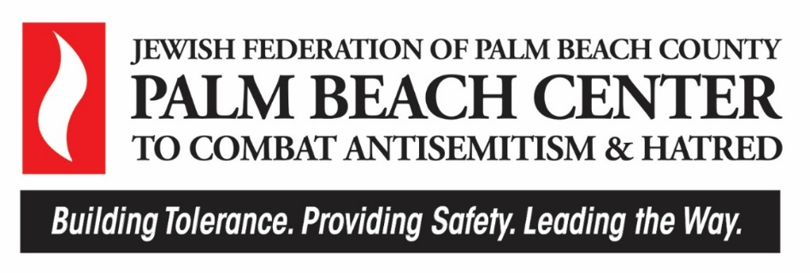

GRANT APPLICATION
FUNDING TO COMBAT ANTISEMITISM, FIGHT HATRED, AND PROMOTE TOLERANCE

Please click this link to complete and submit the application electronically.
Palm Beach Center to Combat Antisemitism & Hatred Grant - Jewish Federation of Palm Beach County
Writing Guidelines:
Answer every question concisely and directly. For items with word counts (e.g. 500 words), stay within the limit; short fields should be one line. Use plain language (bullets if helpful), quantify (numbers/dates), keep narrative/budget/timeline consistent, and write “N/A” with a brief reason if not applicable.
SECTION A: CONTACT INFORMATION
- Name of Proposed Project
- Legal Name of Organization
- Organization Website Address
- Organization Street Address/Location
- Organization Mailing Address (if different from Street Address)
- Executive Director/CEO/Rabbi
- Executive Director/CEO/Rabbi Email Address
- Project Contact Person
- Project Contact Title
- Project Contact Email Address
- Project Contact Telephone Number
SECTION B: ORGANIZATIONAL INFORMATION
- Has your organization received a grant from Jewish Federation Palm Beach County and/or the Palm Beach Center to Combat Antisemitism & Hatred in the last 2 years? Yes or No
- Does your organization use a fiscal sponsor to receive grant money? Yes or No
- Please provide one of the following via an attached PDF:
  - Public charity (including any Religious Organization that is not a synagogue or church): IRS Letter of Determination
  - Fiscal sponsor: Letter with full legal name, contact name, email address, and a copy of their IRS Letter of Determination
  - Synagogue or Church: Letter on letterhead signed by Rabbi, Priest or President/Chair of Board of Directors confirming it is a currently operating house of worship in Florida.
  - School District or Government Entity: Letter on letterhead from an authorized government official attesting to the organization's status as a government entity, or a copy of the legislative act creating the government body.
  - Any Religious Organization that is not a public charity, a synagogue or a church: A statement describing how specifically the proposed grant will further the Federation’s exempt purpose and will not result in any prohibited private benefit. Any grant to such a religious organization will be conditioned on entering into a specific grant agreement with procedures and requirements specific to grantee to ensure the grant is used solely for the purpose for which it is made.
- Disclose any current legal, financial, or reputational improprieties or actions.
  - Please include a link to your organization’s Charity Navigator profile if relevant.
- Organization Mission Statement
- Brief Overview of Programs/Services Provided by Your Organization (maximum 150 words)
- Total Operating Budget of Organization for the Current Fiscal Year
  - Overall funding sources for your organization
- Did someone from your organization attend or view the virtual information session for this grant opportunity? Yes or No
- How did you hear about this grant opportunity? (i.e., social media, community meeting, etc.)
SECTION C: PROJECT INFORMATION
Project Description
- Is this a new or existing program? New Existing Modification of Existing (3 choices)
- Provide a brief, one to two sentence “elevator pitch” describing your project. (If funded, this description may be used for promotional purposes.) (maximum 30 words)
- Target Audience Review (maximum 150 words):
  - Who will be reached, and who will benefit?
  - What strategies will use to maximize engagement?
- Provide a Detailed Project Description, including the following (maximum 500 words):
  - Long Term Goal and Short-Term Objectives (i.e., What steps or efforts will this funding support? What services will be offered?)
  - Timetable, including start and end dates, and any relevant context (e.g., alignment with a school year, summer session, or holiday)
  - Major activities and logistics (including location)
  - Staff roles and effort levels, including volunteers if applicable
  - Collaborators and partners (please list, describe roles, and include a letter of support from each collaborating group or organization in the supporting document section)
  - How is the project innovative?
- Why is your organization a good fit for this work (maximum 150 words)?
Project Impact
- Please describe the anticipated impact of your project by addressing the following (maximum 500 words):
  - Intended outcomes for combating antisemitism, fighting hatred, and promoting tolerance in Palm Beach County.
  - Estimated number of participants who will be directly or indirectly affected.
  - The data or evidence you will collect to demonstrate impact (e.g., surveys, testimonials, observations, pre/post assessments). Please note which tools are already in place and ensure your measures are feasible.
  - The individual responsible for data collection and reporting (include name and title/position).
SECTION D: BUDGET INFORMATION
- What is the total funding request for this proposal? Please include in your total all costs associated with the full implementation of your proposed project regardless of the funding source.
- Are you requesting partial or full funding? Partial Full
- Do you have other funding commitments for the proposed project? Yes No
- Using the linked Project Budget Form, please submit a detailed project budget listing all project expenses and how project activities will be funded, noting funds you are requesting from the Palm Beach Center to Combat Antisemitism & Hatred and other funding sources.
- The form includes instructions.
- Be sure to list all expenses, along with justifications.
- Identify each funding source
You must upload the completed Excel Budget Form to this section.
SECTION E: COMMITMENT TO TRACKING, LEARNING, & REPORTING
We are committed to stewarding resources responsibly and maximizing the impact of funded projects. To ensure accountability and shared learning, all grantees will collaborate with Federation staff to establish key performance indicators (KPIs) and appropriate measurement strategies.
Ongoing Monitoring Requirements:
Grantees agree to:
- Track data directly aligned with intended outcomes.
- Maintain detailed records of activities, expenditures, participant engagement, and progress.
- Provide interim progress updates against agreed-upon milestones, including any deviations from plan and corrective actions taken.
- Submit communications deliverables (e.g., photos, videos, testimonials, case studies) to support Federation reporting and storytelling.
Reporting Requirements:
Grantees agree to submit comprehensive written reports at the midpoint (6 months) and conclusions of the grant period, unless otherwise agreed upon. Reports will include:
- A summary of activities and services delivered
- Progress toward objectives and KPIs
- Financial statements detailing the use of funds
- Challenges encountered and strategies employed to address them
- Outcomes achieved and evidence of impact
Agreement:
By accepting this grant, grantees agree to affirm commitment to these tracking and reporting requirements, including both interim and final reports.
____________________________________________________________________________
SECTION F: ATTACHMENT REQUEST & SIGNATURES
Please attach the following documents:
- Letter of support from each collaborator and/or partner organization, if applicable. Please attach into a single PDF.
- Organization Board Member List
The undersigned attests that the information provided above is true, accurate, and authentic. Two signatures are required
Date of Submission:
Name:
Title:
Are you authorized to sign on behalf of your organization?
Authorized Representative Signature

Additional Authorized Representative
Date of Submission:
Name:
Title:
Are you authorized to sign on behalf of your organization?
Additional Authorized Representative Signature

